**Online diary 2:**

**Title:** To Create a game based around territory acquisition

**Date:** Tuesday 13th October 2020

**Background:**

When creating this game, there was certain criteria that we had to meet to ensure we can get the best marks. Firstly, it had to be 2-4 players where each player must fight each other to try gain territory from one another. This can either be done through conquest, diplomacy or creating an alliance with one another. Furthermore, players must engage in conflict, trading or auctions. This means that we must create some sort of system where they are able to fight one another. This means we had to create siege items such as trebuchets.

**Game:**

Our group had come up with a game called Mental Medieval Conquest Game. This is a turn-based board game which takes place in England during the middle ages. You will be able to gain troops and siege items, alliances and trading between one another is allowed. They can trade items such as gold and wood. They could also buy cards, these cards are grass, water, gold mine, castle and troops. These are all used for defence to improve it and to gain money.

**Rules:**

At the beginning of the game, everyone starts off with a castle, a town and a goldmine with some grass. This will be used as their home base anywhere they can gain gold to be able to trade or buy more cards to better their defence. Turn are decided by a dice roll and during their turn they can 2 things, improve their defence or their offense. The more villages you have, the more gold you can get per turn. Only 2 players in the same area at a time as they will be fighting. The loser would go back to the castle, whereas the winner takes the village and stays there. To win, you must either have the most villages after 40 turns or claim all the beginning castle. You can surrender.

**Design:**

Fig1: Fig2:

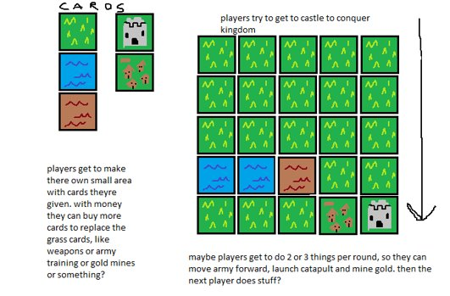 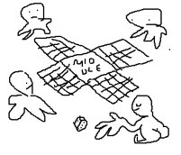

This is a design of our game. There would be a middle part, where all the villages would be for people to conquer whereas everyone would have their own section. Their own section would look like fig1. This means that it would contain their first castle which they have to fortify and protect it from anyone taking it over, so they do not lose. They can fortify the castle by buying the cards on the side. Furthermore, the castle can be placed anywhere the player decides however, after they decide on where they want to place it, they cannot change it during the game as it would mess up the game. Fig2 gives an overview of what the game would look like. As each player would have their own section with the caste and the middle where the villages would be for them to conquer.

This is what my group had come up with. Which consisted of Akash Sroay, Spas Spasov and Steven Smith. We had run into problems with ideas, but eventually we had started to bounce ideas off each other when thinking of certain items during the medieval time. Next time, I would like to test it with another group.